
NAME : BISMA FATIMA
CLASS : CS A
ROLL NO: F24605036
COURSE : INFORMATION SECURITY
COURSE CODE : CS-291
LECTURER : MISS ATTIA ASHRAF

LAB TASK 01

Lab Activities
1. Understanding Virtualization: Write a brief explanation (200 words) of why virtualization is important in information security.
ANS: Virtualization is a fundamental technology in information security, enabling the creation of virtual instances of hardware, operating systems, and storage devices. It allows multiple virtual machines (VMs) to run on a single physical system, each acting as a separate, isolated environment. This isolation is crucial for security, as it prevents malware or attackers in one VM from affecting others or the host machine. For security professionals, virtualization provides a safe way to analyze malware, test security tools, or simulate attacks without compromising a real environment.
Additionally, virtualization supports quick deployment and recovery. For example, snapshots allow systems to be rolled back to a previous state, which is especially useful after a security incident. Virtualized environments also enable better resource allocation and cost efficiency in security labs and enterprise infrastructures.
Virtualization plays a key role in implementing defense-in-depth strategies by supporting sandboxing, network segmentation, and zero-trust architectures. Tools such as hypervisors, containers, and virtual firewalls are all built on virtualization principles. Overall, virtualization enhances flexibility, scalability, and security posture by enabling secure testing, isolation, and efficient management of computing resources.

2. Installing Ubuntu: Document each step taken during the installation process, noting any issues encountered and how they were resolved.
ANS:
System Requirements Checked:
- Minimum 25 GB disk space
- 4 GB RAM
- Bootable USB with Ubuntu ISO (Ubuntu 22.04 LTS used)
Installation Steps:
- Boot from USB Drive
  - Inserted bootable USB and restarted system.
  - Entered BIOS/UEFI and set USB as primary boot device.
  - Saved changes and restarted.
- Ubuntu Boot Menu
  - Selected "Try or Install Ubuntu".
  - System loaded into Ubuntu installer.
- Language and Keyboard Selection
  - Chose English as the language.
  - Selected default US keyboard layout.
- Preparing Installation
  - Chose "Install Ubuntu".
  - Selected "Normal Installation" and checked "Install third-party software".
- Disk Partitioning
  - Selected "Erase disk and install Ubuntu" (for clean install).
  - Reviewed warning about data loss and confirmed.
- Time Zone Selection
  - Chose time zone based on location (e.g., New York).
- User Account Setup
  - Entered full name, computer name, username, and password.
  - Chose "Require my password to log in".
- Installation Process
  - Installer copied files and installed Ubuntu (~20 minutes).
- Installation Complete
  - Clicked "Restart Now".
  - Removed USB drive when prompted.
Issues Encountered and Resolutions:
- Issue: USB not detected during boot.
Resolution: Changed USB port and rechecked boot priority in BIOS.
- Issue: Slow installation speed.
Resolution: Switched to a faster USB 3.0 drive.
Ubuntu installation completed successfully with no critical errors.

Lab Submission Requirements
Submit the following:
1. Screenshots of the Ubuntu installation process.
1. Create a New Virtual Machine:
o Open VMware Workstation Player.
o Select Create a New Virtual Machine from the welcome screen.
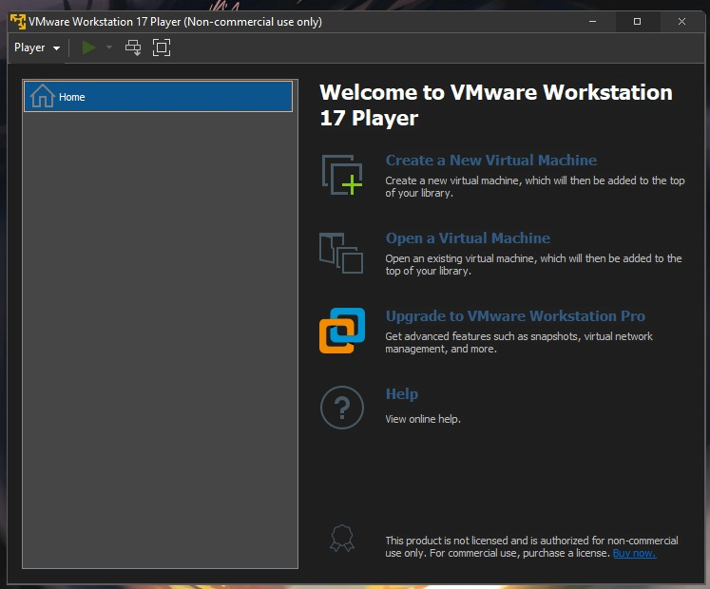
2. Select the Installer Disk Image:
o In the New Virtual Machine Wizard, select “Installer disc image file (ISO)” and browse to the Ubuntu ISO file.
o VMware Player will detect the operating system automatically.
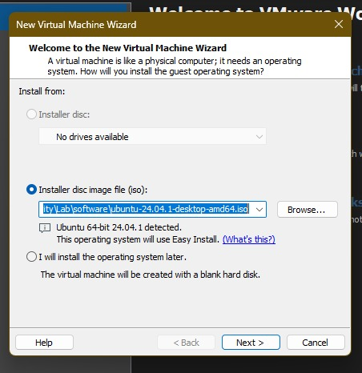
3. Set up the VM Name and Location:
o Name your virtual machine (e.g., "Ubuntu VM").
o Choose where to store the VM on your local disk.
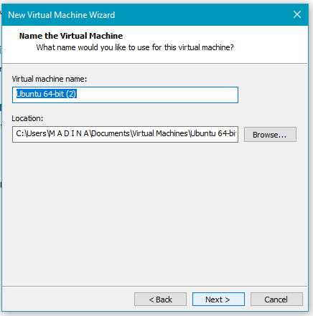
4. Specify Disk Size:
o Set the disk size (minimum 20 GB, recommended 40 GB).
o Choose Store virtual disk as a single file.
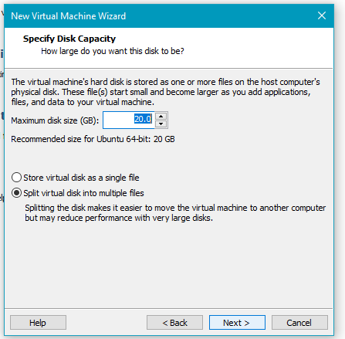
5. Customize Hardware:
o Adjust hardware settings by clicking Customize Hardware:
▪ Memory: Allocate at least 4 GB.
▪ Processors: Use 2 or more cores.
o Click Close, then Finish to complete the VM setup.


2. A short report (300 words) on the importance of virtualization in security.
ANS: The Importance of Virtualization in Information Security
Virtualization is a foundational technology in modern cybersecurity practices. It allows multiple operating systems to run independently on a single physical machine through virtual machines (VMs), using a hypervisor to manage hardware resources. This provides immense flexibility and is especially critical in information security due to the isolation and control it offers.
One of the primary benefits of virtualization in security is environment isolation. Security professionals can create sandboxed environments to analyze malware, test patches, or simulate cyberattacks without risking damage to production systems. If malware compromises a virtual machine, it can be reverted to a clean snapshot within seconds, minimizing downtime and risk.
Virtualization also enhances incident response and recovery. By using snapshots and backups, compromised systems can be quickly restored, ensuring business continuity. Moreover, virtualization enables network segmentation by allowing separate virtual networks for different departments or services, limiting the lateral movement of attackers.
Another key advantage is scalability and efficiency. Security tools like intrusion detection systems (IDS), firewalls, and honeypots can be deployed rapidly in virtual environments. Teams can replicate enterprise networks for training or testing, without the need for additional hardware.
With the rise of cloud computing and containerization, virtualization continues to be essential. It supports zero-trust architectures and microsegmentation, key components in defending against modern cyber threats.

Once the terminal is open, you can type commands.
For example:
- Command To Make a Folder:
Creates a folder named firstfolder.
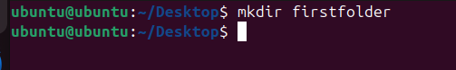

- Command To Make a File:
Creates a file on desktop.
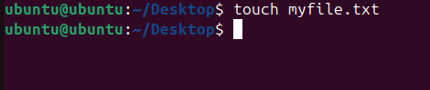

- Command To Write Into The File :
Writes the line into the file .
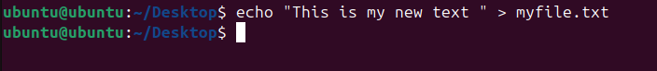

- Command To Change The File Name:
Changes the previous name to the new name.

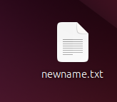
- Check Ubuntu version:
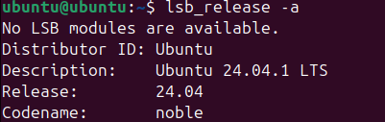
- List files in the current folder:

